**Gibbs High School Theatre Arts Syllabus, Fall 2018**

**Teacher: Crystal Braeuner**

https://www.facebook.com/rsrc.php/v3/y4/r/-PAXP-deijE.gif

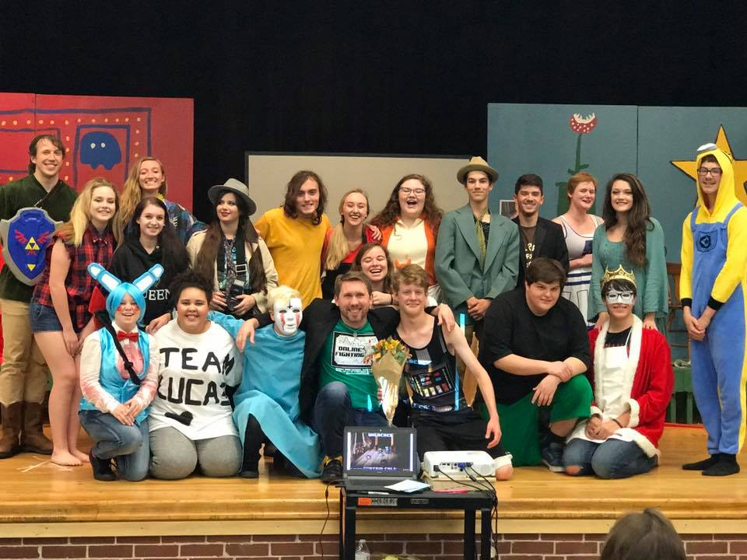

This class covers basic theatre elements, including performance, terminology, technical theatre, etc. While we will review some of these elements, our primary focus will be to enhance our performance techniques and end the semester by presenting a full-length play to the school and the community. **These performances are worth 25% of your grade.** In addition to the performance, a final exam will be given at the end of the term that will count as 10% of the final course grade.

**EXTENSIVE MEMORIZATION AND COMMITMENT IS REQUIRED IN THIS CLASS!**

**Participation is a MUST. Theatre is about DOING, not simply BEING PRESENT!**

**ASSESEMENT/STUDENT WORK:** In this course of study, students will be required to complete the following:

* Class work and text material
* NOTEBOOK for all notes and journals
* Oral work done individually, in pairs, and in groups
* Play and character analysis
* Original plays and monologues
* Memorized plays and/or scenes
* **Resources\***

The Outsiders (play) by Christopher Sergel, The Outsiders (film, 1983, PG), Drink the Wild Air by Staci Swedeen, Check, Please by Jonathan Rand, Playing Scenes from Classic Literature by Joellen Bland, Spare Scenes by Diane Timmerman, Notes on Directing by Frank Hauser,The Stage and the School, Glencoe Publishing Co. 2000,Twentieth-Century American Drama, Prentice Hall 2000, Disney’s Newsies! The Broadway Musical (film, 2017, PG),The Greatest Showman (film, 2017, PG) Three Comedies of American Family Life, Washington Square Press 1961, All in the Timing (partial) (David Ives)

*Parents will be notified of any changes/additions to this list.

* ***Compliance with Instructional Materials Policy & Procedure IFAB:***
  + Several resources (including plays, websites, multimedia, articles, essays, excerpts, etc.) will be used for performance, analysis, etc. I can provide a hardcopy upon request. I will notify parents of any addendums to the syllabus.
  + All objectionable content will be flagged (refer to guidelines in Policy IFAB)
  + If any content is considered objectionable, an immediate alternative will be provided upon request. Please do not hesitate to contact me with any concerns about material I am using in my class.

**\*\*\*NOTE: At the end of the term, a full production will be performed. This year’s production is *The Outsiders.*  Performances will take place November 9-10. Additional details regarding this performance will be announced in the upcoming month. It will require AFTER-SCHOOL participation. Again, participation is mandatory and will be considered part of the final course grade.**

**PLEASE NOTE:** The Theatre Arts classroom (and, by extension, the auditorium) is home to several costumes, props, set pieces, and electrical equipment. While many of these items will be utilized in class and during performances, students will **NOT** be allowed to touch or play with these items without my express permission. Most of these items are extremely expensive and/or delicate, and some can even be dangerous when mishandled. **STUDENTS ARE HELD RESPONSIBLE FOR ANY BROKEN AND/ OR MISSING ITEMS! If an item is damaged, the student will be required to fill out a form detailing the incident and, if necessary, replace the item.**

All policies of Gibbs High School, Knox County, and State of Tennessee will be observed in this class. **NO EXCEPTIONS!!!** In addition, students will observe the following policies of my class, which include the following:

* **Attendance**—Due to the level of commitment involved in this class, attendance will be **closely** monitored. If an absence cannot be avoided (i.e. illness, family emergencies, etc.), it is the **student’s responsibility** to collect make-up work **the first day** he/she returns to class. Each student has up to **3 school days** after a missed classed to turn in make-up assignments (class work, homework, quizzes, tests, projects, etc.) for full credit. After three days, it is considered late and could result in a zero for the assignment. **SEE HANDBOOK FOR ADDITIONAL EXPECTATIONS REGARDING ATTENDANCE.**
* **Tardies**: Excessive tardies will result in an office referral. A tardy occurs when a student arrives (INSIDE the room) after the bell and **before the 15 minute limit for an absence. Arriving to class fifteen (15) or more minutes after the class has begun and checking out of class before the final bell are both considered absences. Consequences for tardies are as follows: On the third tardy, I will contact a parent or guardian**. On the fourth tardy, the student will serve one period of ISS. Any following tardies will result in ISS or suspension.

**THE FOLLOWING ITEMS ARE PROHIBITED AT ALL TIMES IN THE CLASSROOM/AUDITORIUM:**

* Food and drink (water in a closed container/ plastic bottle is acceptable)
* Electric devices (unless they are being used, with permission, for instructional purposes)
* Any other item that detracts from the learning (Ex.—putting on makeup in the middle of class, working on assignments for other classes, etc.).

**CELL PHONES**—Cell phones are to be turned off, not visible and not used in any form or fashion during instruction (unless I have stated otherwise). The consequences for cell phone violations are as follows:

**First Offense—** Cell phone will be confiscated and held by the teacher **for the remainder of the school day.**

**Second Offense—** Cell phone will be confiscated for the remainder of the school day. Student will serve a minimum of one class period in ISS.

**Third Offense—** Cell phone will be confiscated for the remainder of the school day. Student will serve a minimum of one class period in ISS.

(These actions are supported by Knox County Policies and those of Gibbs High School)

* **Respectful Environment***—This is the most important policy. Without it, this class will not work!* Students must treat their instructor and classmate in a considerate manner at all times. This class will require students to perform often, which can make even professionals nervous at times. THIS IS A SAFE, SUPPORTIVE ENVIRONMENT. Thus, heckling, interrupting performances, and ANY other forms of rude behavior will not be tolerated. Remember—we are all in this together. Let’s make it a positive experience!

**Please Note:** While talent is obviously important in an advanced theatre class, be aware that I maintain VERY HIGH EXPECTATIONS. Misconduct of any kind, whether it be in the form of class disruptions, disrespect, or lack of responsibility (i.e. not paying attention, completing assignments, or attending class regularly and on time) will not only result in poor grades, but will also prevent you from getting large roles in our production. Though we will hold auditions, I will make a note of any behavior issues I encounter with you and take them into consideration when casting. **Acting roles do not go to students with negative attitudes—period! No slackers, no prima donnas…you get the picture!**

**CLASS EXPECTATIONS: See the Expectations Handbook for details regarding what is expected in this class.**

**Grading Process:**

1. Assigned Monologue: 5%
2. Film project: 5%
3. PLAY PERFORMANCE: 25%
4. Final Project: 10%
5. Written work: 15%
6. ADDITIONAL WORK (written, performance, service, etc): 40%

Grades will be updated on Aspen **at least once per week.** Thus, parents should have an up-to-date account of their child’s progress at the end of each week. If there is ever a question about a specific grade, please do not hesitate to contact me.

**The grading schedule is as follows:**

**End of first 9 week grading period October 5 (Friday)**

**End of second 9 week grading period December 21st (Friday)**

**The grading scale can be found in the Student Handbook.**

**Parents:** Please contact me with any questions or concerns. You may reach me by phone at **# 689-9130, ext. #72570,** or by email at **crystal.braeuner@knoxschools.org**. I am available for conferences before and after school, as well as during my planning period. Parents are invited to the end of course play and will receive information about the date and time of the play closer to the end of the term.

**\*\*\*NOTE: Class Fee of $10 is due ASAP.\*\*\***

**This fee pays for the scripts and royalties performed by students in class. Please send this fee in to me as soon as possible.**

**A CALL FOR PARENT VOLUNTEERS!**

Dear Parents,

The theatre program at Gibbs High School has grown by leaps and bounds over the past few years. We would like to keep this momentum and provide even more opportunities for our talented students. To do this, we need your help!

If you are interested in volunteering to help with our fall production, please fill out the following and ask you student to return it with the syllabus Acknowledgement Sheet.

NAME (S): _________________________________________

PARENT(S)/GUARDIAN(S) OF: _____________________________

PHONE #: ____________________________________

EMAIL: ______________________________________

BEST TIME(S) TO REACH YOU DURING THE DAY: ________________________________

Please circle any/all areas you might be willing to assist us in this semester:

Marketing/Promotion

Set Building

Costumes

Food/Drink for cast

Selling Concessions

Purchasing/donating concessions

Selling tickets at the door

Tech (sound, lights)

Runner (picking up/delivering items)

Other:

**THANK YOU SO MUCH IN ADVANCE! WE LOVE OUR PARENT VOLUNTEERS!!!!!**